United Kingdom – Fact Sheet
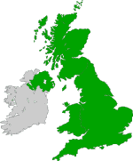
Official name: | United Kingdom of Great Britain and Northern Ireland
Abbreviation: | UK
Capital: | London
Size: | 244,101 km²
Population: | 60 million
Currency: | Pound Sterling
Official language: | English
Local time: | o 2 hodiny menej

Other interesting facts:
The terms United Kingdom, Great Britain and England are often confused. Great Britain comprises England, Wales, and Scotland. The United Kingdom also includes Northern Ireland.

The British flag

The UK flag is called the Union Flag. It is sometimes wrongly referred to as the Union Jack. It is the flag of Great Britain and Northern Ireland.
The flag is actually three flags in one.
It is made up from the:
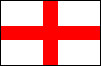
- England flag,

Scotland flag and
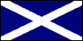


- the patron saint of Ireland's Flag.
The emblems (flags) that appear on the Union Flag are the crosses of three patron saints:
This is Scotland's Flag.
Scotland is represented by the flag of St. Andrew.
It is called the "St Andrews Flag".
This is England's Flag.
England is represented by the flag of St. George.
It is called the "St Georges Flag".
This flag is the Patron Saint of Ireland.
On the Union Flag, Northern Ireland is represented by the flag of St. Patrick.

Together they all make the UK Flag
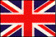

London Tour
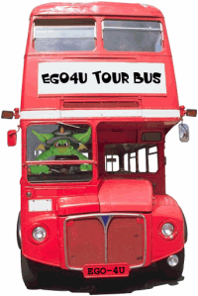

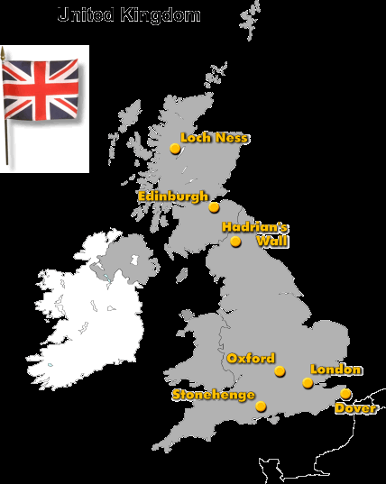
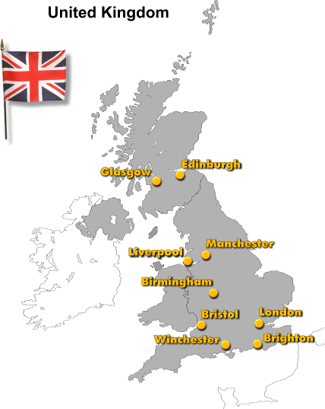

Loch Ness
Loch Ness is a lake between the Scottish towns of Inverness and Fort Augustus. The word loch is Scottish for lake. Loch Ness is about 37 km long and extremely deep, the deepest part is 226 m.
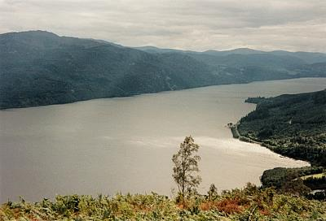
Loch Ness is famous for its friendly monster, Nessie. Most people think that this is only a legend, but every year tourists from all over the world come to Loch Ness and hope that they will see the monster.

Edinburgh
Edinburgh is the capital of Scotland. It has a beautiful old city centre and a castle that lies on a hill above the city.
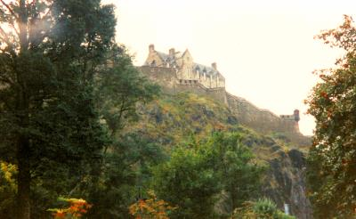
By the way, J. K. Rowling wrote her first Harry Potter book in an Edinburgh coffee-shop.
The location of Edinburgh – capital of Scotland and a World Heritage Site – is spectacular, with the castle high on its rock.
Other attractions include The Scotch Whisky Heritage Centre, where research into whisky making can finish with a sampling one of 270 varieties at the bar;

OXFORD
Oxford is a beautiful university town that is famous all over the world. The University of Oxford is the oldest university in Great Britain; it already existed in the 12th century.
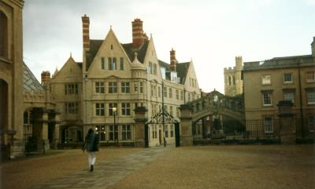

Stonehenge
Stonehenge is a mystical place. Its stone circles are probably more than 4,000 years old. The huge stones come from an area about 30 km north of Stonehenge. Small stones almost 400 km away from Stonehenge.
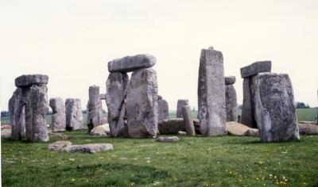
Nobody knows for sure what the function of Stonehenge was. Maybe it was a druid temple. Maybe it was a sacrificial altar. Maybe it was some kind of observatory.
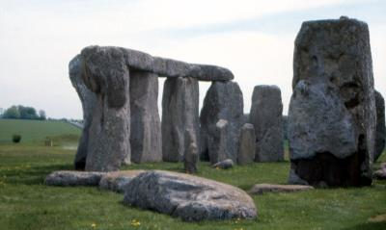

London
London lies on the river Thames and is the capital of the United Kingdom. With about 7 million inhabitants, it is one of the largest cities in the world.
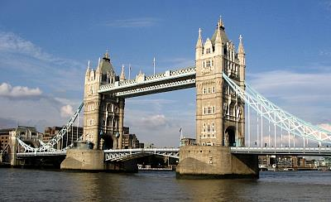

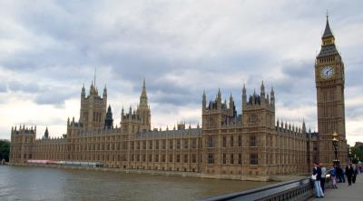

In Love With Shakespeare
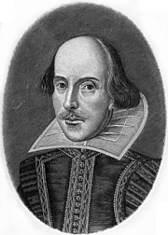
William Shakespeare (1564-1616)
An ambitious, year-long Shakespeare festival starts in 2006 – the 400th anniversary of the playwright’s tragedy, Macbeth.
Shakespeare was born on April 23, 1564 and died on his birthday in 1616, aged 52. The festival will be launched over his birthday weekend when, following tradition, boys from King Edward VI Grammar School, where he was a pupil, lead townspeople, actors and scholars in the Birthday Procession, carrying flowers to his grave in the chancel of the ancient Holy Trinity Church where he was baptised and worshipped. Shakespeare’s epitaph takes the form of a curse, which wasn’t uncommon in those days as he wanted to ensure his bones were not removed.
Shakespeare’s life and times can be followed at the family’s five houses in Stratford-upon-Avon. Shakespeare’s Birthplace is the original family home, where his father ran a prosperous business as a glove maker and wool dealer. The Visitor Centre’s exhibition is excellent and there is even an original school desk covered in graffiti! Shakespeare bought New Place for his wife Anne Hathaway and their children when he was working in London. He retired to Stratford in 1610 and died there. The house was demolished in the 18th century but the Great Garden is preserved with a fine Elizabethan Knot Garden. His granddaughter owned the adjoining Nash’s House.
I fell in love with Hall’s Croft when I first went through the front door. Perhaps it is the friendly ghosts who reputedly appear to welcome visitors, especially the kindly Tudor lady in a blue dress. Victorian school children have been seen playing in the garden and badges in the gift shop mysteriously spinning across the floor.
Halls Croft was the home of Shakespeare’s daughter Susanna. Her husband Dr. John Hall was an eminent physician and there are some pretty intimidating surgical instruments on display as well as fascinating accounts of the treatment of disease and the devastating effects of the plague. The house still has the intimacy of a family home with open fireplaces, stone flagged floors and fine furniture of the period.
Shakespeare’s appearance continually intrigues ordinary people and experts worldwide as no known guaranteed likeness exists.

The Education System in the UK
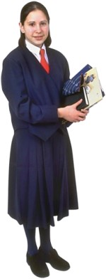In this text you will find general information on the education system in the UK. As there are separate education systems in England, Scotland, Wales and Northern Ireland, the actual ages etc. might vary a little.
School in the UK is compulsory between the ages of five and sixteen. Children younger than five can go to a toddler group (accompanied by a parent), playgroup or nursery school.
Compulsory schooling begins at the age of five. Pupils first attend primary school, which lasts for six years. Often primary school in the UK is divided into infant school (the first two years) and junior school (the following 4 years).
After primary school, students go to secondary school until they are sixteen (practical emphasis) or 18 (secondary school with 6th form - academic emphasis).
The school year consists of three terms. Students have about 12-13 weeks of holiday per school year.
Age |  | School
< 5 |  | nursery school
5-11 |  | primary school
oder | 5-7 | infant school
oder | 7-11 | junior school
11-18 |  | secondary school with 6th form
oder | 11-16 | secondary school
oder | 16-18 | 6th form college

Classes
At primary school, classes run Monday to Friday from about 9 a.m. to 3 p.m. There are usually between 25 and 35 pupils in one class.
At secondary school, classes also run Monday to Friday, but are usually from about 8.45 to 3.30. Gifted and talented students can choose to enter for examinations early (one year or several terms) and then take additional courses in these or other subjects.

Grading Scale
In the UK (as in other English speaking countries) letter grades are used in reports.
- A > 80% (excellent)
- B > 70% (very good)
- C > 60% (improvement needed)
- D > 50% (close fail)
- E > 40% (fail)
- F < 40% (fail)
In general, only grades A to C are a 'pass'. Still, in the UK no student has to repeat a year – weak students can take extra lessons at school.

School Uniforms
It is common for students in the UK to wear school uniforms. They consist of:
- blazer or sweater with school logo
- shirt and tie or polo shirt / t-shirt
- dark trousers or dark skirt
- black shoes
At some schools, students are required to wear a shirt and a tie, other schools only require a t-shirt or sweater. The colour of the uniform also depends on the school – blazer, sweater, trousers and skirt are usually blue, grey, green or brown.

English Kings & Queens
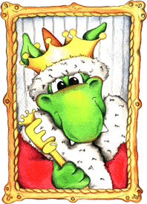
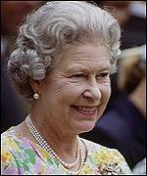Elizabeth II (1952-present)
Queen Elizabeth II was born on April 21, 1926 in London. Her birthday is officially celebrated in Britain on the 3rd Saturday of June each year.
Queen Elizabeth Il is a 'constitutional monarch'. This means that although she is officially the head of the state, the country is actually run by the government, led by the Prime Minister.
The Queen lives at Buckingham Palace.

The Official Title of the Queen
'Elizabeth the Second, by the Grace of God of the United Kingdom of Great Britain and Northern Ireland'.
When did Queen Elizabeth come to the throne?
Queen Elizabeth II ascended the throne on February 6, 1952 upon the death of her father, King George VI. Her Coronation, at Westminster Abbey, followed on June 2, 1953.
Queen Elizabeth II is the United Kingdom's Head of State. She is queen of 16 former British colonies, including Australia, Canada and New Zealand; and head of the Commonwealth, a multinational body created after the dissolution of the British empire.

Who will come the British throne next?
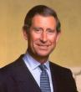
HRH Prince Charles, The Prince of Wales
Prince Charles is presently heir to the British throne. He will not become king until his mother, Queen Elizabeth, abdicates (gives up the throne), retires or dies. When either of these happen, Prince Charles may abdicate and pass the throne to his eldest son Prince William.

Saint George's Day

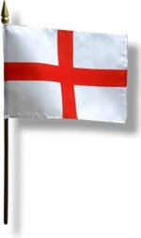
Flag of England, St George's Cross
Saint George is the patron saint of England and the Saint George's Cross (a red cross on a white background) is used as England's national flag. Saint George's Day (23 April) is a National Day in England. Once an important holiday, it is, however, not celebrated that much anymore - it's not even a public holiday.
Saint George lived in the third century. He served as a soldier in the Roman Empire where he even became a member of the personal guard of the Roman Emperor Diocletian. When in 303, however, the emperor ordered the persecution of Christians, George dared to criticize the Diocletian and to confess that he was a Christian, too. This enraged Diocletian and so George was tortured and executed as a traitor on 23 April 303.
Saint George is probably best known for his killing a dragon. Legend has it that a fierce dragon lived near a town called Silene. Every day, the people of Silene had to feed the dragon a virgin, who was chosen by lot. One day the princess was to be sacrificed, but George hurried to help her. With his lance called Ascalon, George killed the dragon and saved the princess. The king and the people of the town were so happy that they wanted to reward George. George asked them to convert to Christianity and so they did.

Saint Patrick’s Day
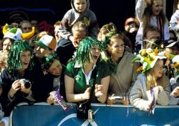Every 17 March, Irish people all over the world celebrate St. Patrick’s Day in honour of Saint Patrick, the patron saint of Ireland.
When St. Patrick was born, his name actually was not Patrick but Maewyn. He grew up in Wales, but when he was 16, people kidnapped him and sold him into slavery in Ireland.
Maewyn spent six years as a slave in Ireland, but then he escaped and went to Gaul in France where he studied in a monastery for 12 years. Finally, Maewyn became a bishop and adopted the Christian name Patricius (in English: Patrick).
Later Patrick decided to go back to Ireland. Unlike many other missionaries before him, Patrick successfully converted Irish pagans to Christianity because he knew a lot about Irish life and their gods. So Patrick for example did not simply introduce the Christian cross – he put a sun behind it because he knew that the sun was an important symbol for the Irish. The so called Celtic Cross therefore is a cross with a circle symbolising the sun.
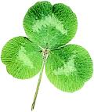Furthermore, Patrick explained the holy Trinity (Father, Son, Holy Spirit) with the help of a shamrock, which grows everywhere in Ireland. The shamrock has three equally sized leaves and Patrick used this to show how the Father, the Son and the Holy Spirit could exist as separate elements of the same entity.
There are several legends about St. Patrick, for example that he banned all snakes from Ireland (still now there are no snakes in Ireland).
Patrick died on 17 March 461. That day now is a national holiday in Ireland and there are parades in the streets and music everywhere. Not only in Ireland – Irish emigrants took this tradition all over the world. So there will most probably be a St. Patrick’s Day party in an Irish pub near you.

The Highland Games
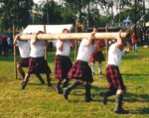In the 11th century, Scottish King Malcolm III organised contests in a Scottish village called Braemar to find the strongest and fastest men in his kingdom. Those who were the strongest became the king’s bodyguards and those who were the fastest became his couriers. The Highland Games were a major attraction and many people came to Braemar when the contest was held. Some wanted to take part, others just came as visitors.
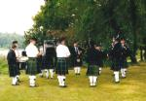Now the Highland Games do not only take place in Scottish villages and towns, but also in many other countries where Scots have settled. And today's games also attract many visitors. This is mainly because of the spectacular events at the games, above all the caber toss. A caber is a log, it is 5 metres long and weighs about 45 kg. The athlete holds the caber by one end and tries to throw it so that it lands on the other end and then falls away from the thrower.
Other events of the Highland Games are for example hammer throw, shot put or tug of war (rope pulling). There are also competitions in bag piping and Scottish dancing.

Easter
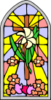At Easter, Christians celebrate the resurrection of Jesus Christ. The Holy Week, as the week before Easter Sunday is called, starts on Palm Sunday. That day marks the entrance of Jesus into Jerusalem where he was welcomed by a large crowd who spread branches of palm trees on his path and greeted him:
Holy Thursday remembers the Last Supper at which Jesus blessed bread and wine and gave it to his disciples telling them that it was his body and his blood. Jesus also told his disciples that one of them would betray him, and later that night Jesus was betrayed by Judas.
Good Friday commemorates the crucifixion. First Jesus was taken to Pontius Pilate to be sentenced to death. Pilate did not want Jesus to be crucified, but he had no other chance. In order to demonstrate, however, that he was not to blame for Jesus' death, Pilate washed his hands in front of the people, which was the origin of the famous saying »I wash my hands of it«:
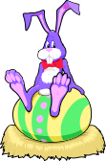
Whilst Easter is a major holiday of the Christian church, nonbelievers have something to celebrate as well: the return of spring. Back then, hares and eggs were seen as symbols of new life–this is why today eggs and bunnies are popular Easter decorations. By the way, the European custom of egg rolling has made its way across the ocean and is now quite common in the USA, too. It has even become an Easter Monday tradition to do "egg rolling" on the lawn of the White House.
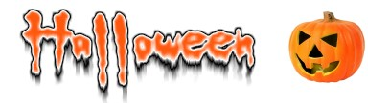
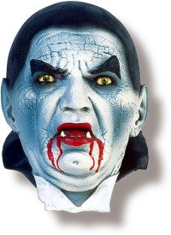

Christmas in England
In English speaking countries, children don’t get their presents on Christmas Eve (24 December). Santa comes at night when everyone is asleep. Santa’s reindeer can fly and take him from house to house. They land on the roofs of the houses and then Santa climbs down the chimney to leave the presents under the Christmas tree.
In the morning of Christmas Day (25 December), children usually get up very early to unwrap their presents. Then they have plenty of time to play with their new toys.
Christmas dinner is served in the early afternoon. Most people eat turkey and sprouts and a Christmas pudding.
26 December is called Boxing Day. It hasn’t always been a holiday. People used to go back to work on that day where their bosses gave them little Christmas presents in small boxes. That’s why the day is called Boxing Day.

Trooping the Colour
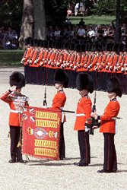Trooping the Colour is a spectacular and colourful military parade that marks the official birthday of the Queen (whose real birthday is on 21 April). Each June, the parade takes place in London and is broadcasted on TV so that millions of people around the globe can enjoy the event.
The custom of Trooping the Colour dates back to the 17th century. In battle, brightly-coloured flags–called coulours–where used so that soldiers could identify their troops. Every regiment had their own colour, and in order to familiarise each man with the flag of their regiment, it became a custom to display–or troop–the colour in front of the soldiers each morning.
In 1805, the tradition started to hold the ceremony as a birthday parade for the Sovereign. The first king to be honoured in that way was George III (who was born on 4 June 1738). During his reign, the weather must have been so fine at his birthday parades that ever since Trooping the Colour has been held in May/June–regardless of the monarch’s real birthday.
Trooping the Colour is now also known as The Queen’s Birthday Parade and usually takes place on the second or third Saturday in June. The parade is held by the Queen’s Household Division that comprises the Household Cavalry (the Life Guards and the Blues & Royals) and five regiments of Foot Guards: Grenadier Guards; Coldstream Guards; Scots Guards; Irish Guards and Welsh Guards. Every year, the colour is trooped by another regiment of the Foot Guards.
About 1400 soldiers, 200 horses and 400 musicians march from Buckingham Palace along The Mall to Horse Guards Parade and back again on that day. If you happen to be in London for Trooping the Colour, the best place to watch the parade is The Mall. Make sure, however, to arrive early as lots of people will be there to get a glimpse of the troops (or even of the Queen herself).

Tower Bridge
Tower Bridge is the most famous bridge in London. It opened in 1894. The bridge only needs 90 seconds to lift. This happens about 500 times a year.
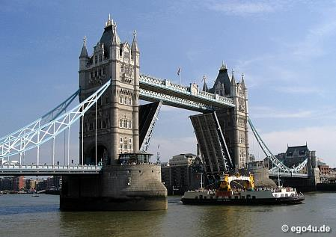
Tower Bridge

HMS Belfast
Her Majesty’s Ship – HMS Belfast played an important role during World War II. The ship weighs 11,500 tons and is a museum now.
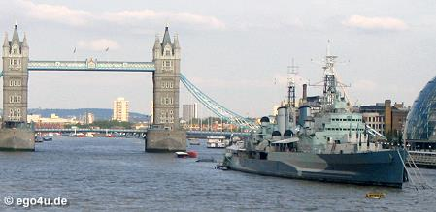
HMS Belfast

London Eye
The London Eye offers a spectacular view over London and its surroundings. With its 135 m height, it is the biggest observation wheel in the world.
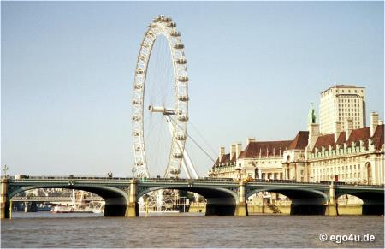
London Eye, seen over Westminster Bridge
Each capsule can carry 25 people. So in one day, the 32 capsules of the wheel carry over 15,000 visitors. A flight lasts 30 minutes and you can see up to 40 km in each direction.

Houses of Parliament
The official name of the Houses of Parliament is Palace of Westminster. This is because it was the royal palace before the king moved to Whitehall Palace in 1529. Now the palace is home to the United Kingdom Parliament.
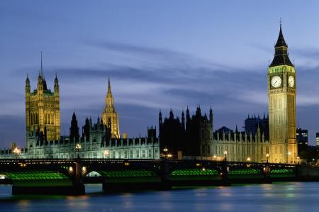
The Houses of Parliament, seen over Westminster Bridge
On 5 November 1605, some radical Catholics wanted to blow up the Houses of Parliament. But they were not successful. Guards searched the cellars of the Palace and found 36 barrels of gunpowder. Every year on 5 November people commemorate Guy Fawkes Day (or Gunpowder Day) with fireworks and bonfires.
In 1834, a fire destroyed most of the palace. Between 1840 and 1888, Sir Charles Barry rebuilt the Palace of Westminster and also added the famous clocktower that everybody knows as Big Ben. Actually, it is only the name of the biggest bell in the clock tower, which rings the hour. Big Ben takes its name from Sir Benjamin Hall, who ordered the casting of the 16 ton bell in 1856.

Buckingham Palace
Buckingham Palace is the Queen’s residence in London. When the queen is in the palace, you can see the Royal Standard on the roof of the palace. If the Queen is not in the palace, you see the Union Jack.
Buckingham Palace has 600 rooms, a park, a swimming-pool and even a cinema. The royal family lives in the north wing of the palace.
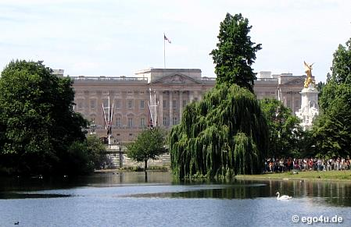
Buckingham Palace and the Victoria Memorial
The Changing of the Guard is at 11:30 am. It takes place every day in summer and every second day for the rest of the year.
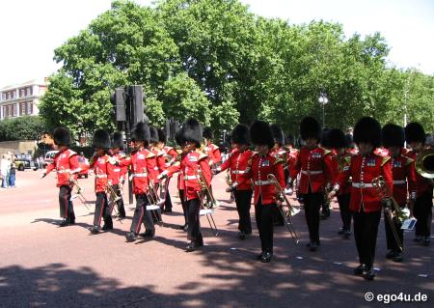
The Changing of the Guard

Horse Guards
In Whitehall you can see the Queen’s Life Guard – the Horse Guards. The Mounting of the Guard takes place every day at 11 am (10 am on Sundays).
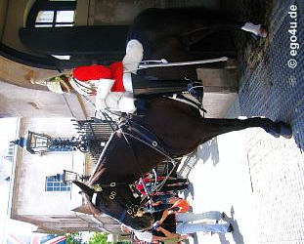
Horse Guards

Piccadilly Circus
Piccadilly Circus is the centre of London’s nightlife. Its neon lights are famous all over the world. The Eros fountain is a great meeting place if you want to go to one of the plenty restaurants, bars, nightclubs or theatres nearby.
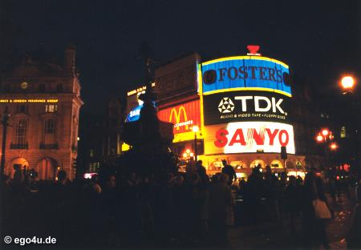
Piccadilly Circus by night
The Rock Circus with wax figures of famous rock stars, is also at Piccadilly Circus. At the entrance of the museum you get headphones, so you can hear the stars sing. The highlight of the museum is a spectacular concert with moving wax figures.
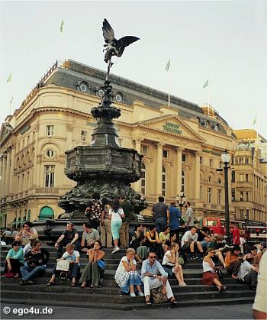
Statue of Eros at Piccadilly Circus

Madame Tussaud’s
Madame Tussaud's is a famous wax museum with celebreties of entertainment, sport and politics. It is one of the most popular museums in London.
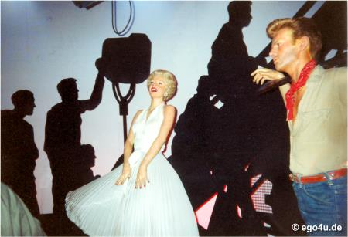
Marilyn Monroe at Madame Tussaud's
Madame Tussaud was born in France where she learnt how to make waxworks. In 1802, she came to England with her collection and travelled around Great Britain and Ireland. In 1835, she finally opened a wax exhibition in London. Her last work was her self-portrait, which is at the entrance of the museum. Madame Tussaud was 89 years old when she died in 1850.

What are Britain’s National Emblems?
What are the Symbols of England, Scotland and Wales?
Each country in Britain has its own patron saint and floral emblem:
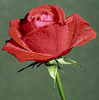 | England - St. George and the Rose  The national flower of England is the rose. The flower has been adopted as England’s emblem since the time of the Wars of the Roses - civil wars (1455-1485) between the royal house of Lancaster (whose emblem was a red rose) and the royal house of York (whose emblem was a white rose).

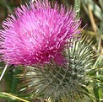 | Scotland - St. Andrew - the Thistle and Scottish Bluebell  The national flower of Scotland is the thistle, a prickly-leaved purple flower which was first used in the 15th century as a symbol of defence. The Scottish Bluebell is also seen as the flower of Scotland.

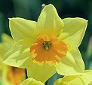 | Wales - St. David and the Daffodil  The national flower of Wales is the daffodil, which is traditionally worn on St. David’s Day. The vegetable called leek is also considered to be a traditional emblem of Wales.

There are many explanations of how the leek came to be adopted as the national emblem of Wales. One is that St David advised the Welsh, on the eve of battle with the Saxons, to wear leeks in their caps to distinguish friend from foe. As Shakespeare records in Henry V, the Welsh archers wore leeks at the battle of Agincourt in 1415.

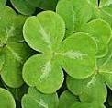 | Northern Ireland - St. Patrick and the Shamrock  The national flower of Northern Ireland is the shamrock, a three-leaved plant similar to clover. An Irish tale tells of how Patrick used the three-leafed shamrock to explain the Trinity. He used it in his sermons to represent how the Father, the Son, and the Holy Spirit could all exist as separate elements of the same entity. His followers adopted the custom of wearing a shamrock on his feast day.  TYPICAL TRADITIONAL ENGLISH DISHES  Please note: We have mainly written about England, as that is the country within the UK where our students live. We would be very happy for schools and visitors to send us information we can add to our website on Wales and Scotland.  Traditional English dishes have had competition from other dishes over the years. Despite this, if you visit England, you can still be served up the traditional foods we have been eating for years.  This page contains some of our most popular traditional dishes.  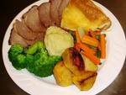Main meal dishes  Click here to find out what we eat for Christmas dinner  Roast beef and Yorkshire pudding  This is England's traditional Sunday lunch, which is a family affair.  Recipe  Yorkshire Pudding  This dish is not usually eaten as a dessert like other puddings but instead as part of the main course or at a starter.  Yorkshire pudding, made from flour, eggs and milk, is a sort of batter baked in the oven and usually moistened with gravy.  The traditional way to eat a Yorkshire pudding is to have a large, flat one filled with gravy and vegetables as a starter of the meal. Then when the meal is over, any unused puddings should be served with jam or ice-cream as a dessert. text taken from and copyright of projcetbritain.com  Recipe  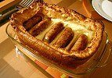  Toad-in-the-Hole (sausages covered in batter and roasted.)  Similar to Yorkshire Pudding but with sausages placed in the batter before cooking. (See photo right) text taken from and copyright of projcetbritain.com  Recipe  Roast Meats ( cooked in the oven for about two hours)  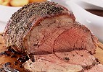  Typical meats for roasting are joints of beef, pork, lamb or a whole chicken. More rarely duck, goose, gammon, turkey or game are eaten.  Beef is eaten with hot white horseradish sauce, pork with sweet apple sauce and lamb with green mint sauce.  Fish and chips  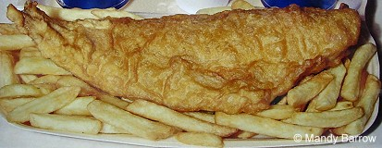  Fish (cod, haddock, huss, plaice) deep fried in flour batter with chips (fried potatoes) dressed in malt vinegar. This is England's traditional take-away food or as US would say "to go". Fish and chips are not normally home cooked but bought at a fish and chip shop ("chippie" ) to eat on premises or as a "take away"  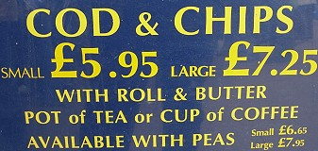  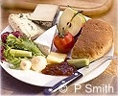  Ploughman's Lunch  This dish is served in Pubs. It consists of a piece of cheese, a bit of pickle and pickled onion, and a chunk of bread. text taken from and copyright of projcetbritain.com  See a sample menu of food served in pubs  Shepherds' Pie  Made with minced lamb and vegetables topped with mashed potato)  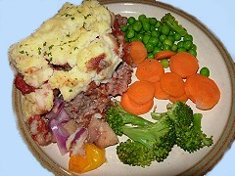  Recipe  Cottage Pie (pictured right)  Made with minced beef and vegetables topped with mashed potato. (Pictured right)  Recipe  Gammon Steak with egg (Gammon is ham)  Lancashire Hotpot text taken from and copyright of projcetbritain.com  A casserole of meat and vegetables topped with sliced potatoes.  Recipe  Pie and Mash with parsley liquor  A very traditional East End London meal.  The original pies were made with eels because at the time eels were a cheaper product than beef. About fifty years ago, mince beef pies replaced the eels and have now become the traditional pie and mash that people know.  The traditional pie and mash doesn't come without its famous sauce known as liquor which is a curious shade of green and definitely non-alcoholic. The liquor tastes much nicer than it looks (it's bright green!).  Jellied eels are also an East End delicacy often sold with pie and mash  Bubble & Squeak text taken from and copyright of projcetbritain.com  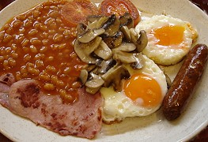  Typically made from cold vegetables that have been left over from a previous meal, often the Sunday roast. The chief ingredients are potato and cabbage, but carrots, peas, brussels sprouts, and other vegetables can be added. The cold chopped vegetables (and cold chopped meat if used) are fried in a pan together with mashed potato until the mixture is well-cooked and brown on the sides. The name is a description of the action and sound made during the cooking process.  Recipe  English breakfast text taken from and copyright of projcetbritain.com  Eggs, bacon, sausages, fried bread, mushrooms, baked beans  Bangers and Mash (mashed potatoes and sausages).  Bangers are sausages in England. (The reason sausages were nicknamed bangers is that during wartime rationing they were so filled with water they often exploded when they were fried.)  Recipe  Black Pudding (Blood Pudding)  Looks like a black sausage. It is made from dried pigs blood and fat). Eaten at breakfast time Recipe  Black pudding recipes vary from region to region, some are more peppery and some are more fatty than others. text taken from and copyright of projcetbritain.com  More information  Bacon Roly-Poly (made with a suet pastry)  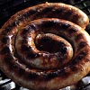  Cumberland sausage  This famous pork sausage is usually presented coiled up like a long rope  The Traditional English Breakfast  The traditional English breakfast consists of eggs, bacon, sausages, fried bread, baked beans and mushrooms. Even though not many people will eat this for breakfast today, it is always served in hotels and guest houses around Britain.  The traditional English breakfast is called the 'Full English' and sometimes referred to as 'The Full English Fry-up'.  LUNCH  What is a typical English lunch?  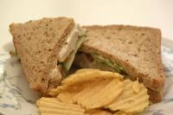  Many children at school and adults at work will have a 'packed lunch'. This typically consists of a sandwich, a packet of crisps, a piece of fruit and a drink. The 'packed lunch' is kept in a plastic container.  Sandwiches are also known as a 'butty' or 'sarnie' in some parts of the UK.  My favourite sandwich is prawn and mayonaise. I also love tuna and mayonaise and ham and pickle sandwiches.  See a sample menu of food served in pubs  Sample menu of food served for School Dinners  DINNER  The evening meal is usually called 'tea', 'dinner' or 'supper'.  What is a traditional English Dinner?  A typical British meal for dinner is meat and "two veg". We put hot brown gravy, traditionally made from the juices of the roast meat (but more often today from a packet!) on the meat and usally the vegetables. One of the vegetables is almost always potatoes.  This traditional meal is rarely eaten nowadays, a recent survey found that most people in Britain eat curry! Rice or pasta are now favoured as the 'British Dinner'.  Vegetables grown in England, like potatoes, carrots, peas, cabbages and onions, are still very popular. We can also buy vegetables from many countries all through the year  Pies in England  Pies are very popular in England. Pies are a baked dish consisting of a filling such as chopped meat or fruit enclosed in or covered with pastry ( a mixture of flour and butter).  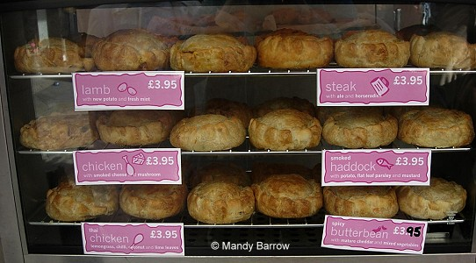  Favourite meat (savoury) pies include:  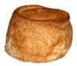  Pork pie  A pork pie consists of pork and pork jelly in a hot water crust pastry and is normally eaten cold. Recipe  Steak and Kidney pie  A traditional English dish consisting of a cooked mixture of chopped beef, kidneys, onions, mushrooms and beef stock. This mixture is placed in a pie or casserole dish, covered with a pastry crust and baked until crisp and brown.  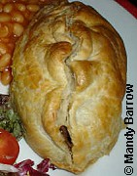  Cornish pastie / Cornish pasty  A type of pie, originating in Cornwall, South West England. It is an oven-cooked pastry case traditionally filled with diced meat - nowadays beef mince (ground beef) or steak - potato, onion and swede. It has a semicircular shape, caused by folding a circular pastry sheet over the filling. One edge is crimped to form a seal.  Recipe  Cornish pasty in the days of the miners, used to be half savoury and half sweet, all wrapped in one piece of pastry. That way it was like a main course and dessert all in one.  Stargazy Pie  Herrings are cooked whole in a pie. with their heads looking skyward and tails in the middle.  Favourite fruit (sweet) pies include:  - Apple pie  - Rhubarb pie,  - Blackberry pie,  - A mixture of fruits such as apple and rhubarb or apple and blackberry.  What sports do you play in Britain?  Please note: We have mainly written about England, as that is the country within the UK where our students live. We would be very happy for schools and visitors to send us information we can add to our website on Wales and Scotland.  Sports play an important part in the life in Britain and is a popular leisure activity.  Many of the world's famous sports began in Britain, including cricket, football, lawn tennis, golf and rugby  England's national sport is cricket although to many people football (soccer) is seen as our national sport. Football is our most popular sport. Some of England's football teams are world famous, the most famous being Manchester United, Arsenal and Liverpool.  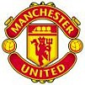  Cricket  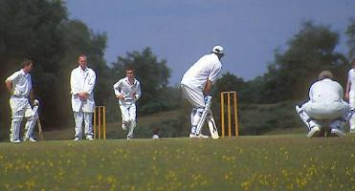  Cricket is played on village greens and in towns/cities on Sundays from April to August  The rules of cricket became the responsibility, in the 18th century, of the Marylebone Cricket Club(MCC), based at Lord’s cricket ground in north  London.  How to play Cricket  Teams are made up of 11 players each. They play with a ball slightly smaller than a baseball and a bat shaped like a paddle. Two batters stand in front of wickets, set about 20 metres apart. Each wicket consists of three wooden rods (stumps) pushed into the ground, with two small pieces of wood (bails) balanced on top. A member of the opposing team (the bowler) throws the ball towards one of the batters, who must hit the ball so that it does not knock a bail off the wicket. If the ball travels far enough, the two batters run back and forth between the wickets while the fielders on the opposing team try to catch the ball. The game is scored according to the number of runs, which is the number of times the batters exchange places.  Football (Soccer)  Football is undoubtedly the most popular sport in England, and has been played for hundreds of years.  In the English Football League there are 92 professional clubs. These are semi-professional, so most players have other full-time jobs. Hundreds of thousands of people also play football in parks and playgrounds just for fun.  The highlight of the English football year is the FA (Football Association) Cup Final each May.  Rugby  Rugby originated from Rugby school in Warwickshire. It is similar to football, but played with an oval ball. Players can carry the ball and tackle each other. The best rugby teams compete in the Super League final each September.  For many years Rugby was only played by the rich upper classes, but now it is popular all over the country. There are two different types of rugby - Rugby League, played mainly in the north of England, and Rugby Union, played in the rest of England, Scotland, Wales and Ireland. England, Scotland, Wales and Ireland, together with France and Italy, play in an annual tournament called the Six Nations.  American Football derived from our game of Rugby also Baseball derived from the old English game of Rounders.  Tennis  The world's most famous tennis tournament is Wimbledon. It started at a small club in south London in the nineteenth century. It begins on the nearest Monday to June 22, at a time when English often have the finest weather. Millions of people watch the Championships on TV live.  It is traditional for visitors to eat strawberries and cream whilst they watch the tennis.  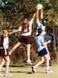Netball  Netball is the largest female team sport in England. The sport is played almost exclusively by women and girls, although male participation has increased in recent years.  Basketball  Over 3 million people participate in basketball in the UK.  Golf  Scotland is traditionally regarded as the home of golf. There are over 400 golf courses in Scotland alone. The most important golf club in Scotland is in the seaside town of St. Andrews, near Dundee.  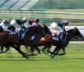Horse racing  Horseracing, the sport of Kings is a very popular sport with meetings being held every day throughout the year. The Derby originated here, as did The Grand National which is the hardest horse race in the world.  Horse racing and greyhound racing are popular spectator sports. People can place bets on the races at legal off-track betting shops. Some of the best-known horse races are held at Ascot, Newmarket, Goodwood and Epsom.  Ascot, a small town in the south of England, becomes the centre of horse-racing world for one week in June. It's called Royal Ascot because the Queen always goes to Ascot. She has a lot of racehorses and likes to watch racing.  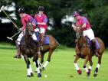Polo  Another equestrian sport is polo, brought to Britain from India in the 19th Century by army officers. It is the fastest ball sport in the world.  Polo is played with four men on horses to a team. A ball is hit with a stick towards the goal, one at each end of a 300 yard long by 160 yard wide field...  Find out more here ....  Table Tennis (ping pong)  Table tennis was invented in England in 1880. It began with Cambridge University students using cigar boxes and champagne corks.  Although the game originated in England, British players don't have much luck in international championships.  Badminton  Badminton takes its name from the Duke of Beaufort’s country home, Badminton House, where the sport was first played in the 19th century.  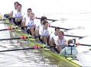University Boat Race  In the nineteenth century, students at Oxford and Cambridge, Britain's two oldest universities, were huge fans of rowing. In 1829, the two schools agreed to hold a race against each other for the first time on the Thames River. The Oxford boat won and a tradition was born. Today, the University Boat Race is held every spring in either late March or early April.  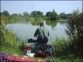Fishing (Angling)  Angling is one of the most popular sports in the UK, with an estimated 3.3 million people participating in the sport on a regular basis. Fishermen can be see sitting beside rivers and lakes.  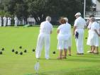Bowls  The two main forms of bowls are lawn flat green (outdoor and indoor) and crown green.  Boxing  Boxing in its modern form is based on the rules established by the Marquess of Queensberry in 1865. In the UK boxing is both amateur and professional, and strict medical regulations are applied in both.  Swimming  Swimming is also a popular pastime and enjoyed by people of all ages.  Martial arts  Various martial arts, mainly derived from the Far East, are practised in the UK, such as judo and karate.  Darts  Darts is a very popular pub game. The game of darts, as it is today, was invented in the north of England in a town called Grimsby. However, the origins of the game date back to at least the Middle Ages.  Boxing Day Hunts  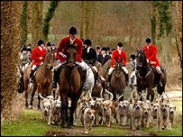  Traditionally Boxing Day is a day for fox hunting. The huntsmen and huntswomen ride horses. They use dogs too. The dogs (fox hounds) follow the smell of the fox. Then the huntsmen and huntswomen follow the hounds.  Before a Boxing Day hunt, the huntsmen and huntswomen drink hot wine. But the tradition of the December 26th is changing. Now, some people want to stop Boxing Day hunts (and other hunts too) They don't like fox hunting. For them it is not a sport - it is cruel.
  Back to food index | Christmas Dinner
  "Harry’s mouth fell open. The dishes in front of him were now piled with food. He had never seen so many things he liked to eat on one table: roast beef, roast chicken, pork chops and lamb chops, Yorkshire pudding, peas, carrots, gravy, ketchup and, for some strange reason, mint humbugs."
  Harry Potter and the Philosopher’s Stone, J. K. Rowling
  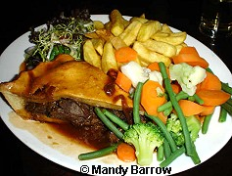 | These three platefuls of food were served up in a pub.  I would say that they are enormous portions and not what a typical British person would eat in one sitting.
  Steak and Kidney Pie with chips and salad
  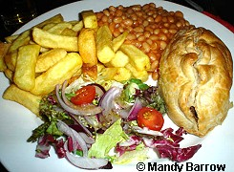 | 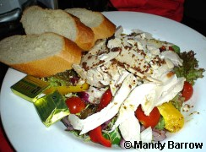
  Cornish Pastie with chips, baked beans and salad | Chicken Salad
  Did you know?
  The first set of laws of the game of football, or soccer as it is known in the US, date from the formation of The Football Association in England in 1863.
  Did you know?
  Wimbledon is the oldest of all the major tennis tournaments beginning in 1877. The rewards of prize money began in 1968 when the total purse allocated was £26,150 (about $40,000).
Houses in England
Please note: We have mainly written about England, as that is the country within the UK where our students live. We would be very happy for schools and visitors to send us information we can add to our website on Wales and Scotland.
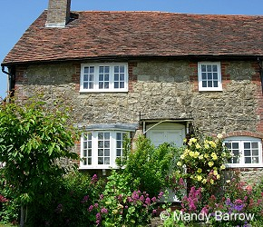
Information on houses in England
Photographs of Typical English Houses in England
What is it like inside an English house? A report by a 10 year old boy
House Names | Virtual House - Can you identify the different rooms?
Photographs of Houses through History
Photographs of houses alongside the River Thames
Most people in England live in urban areas. Towns and cities are spreading into their surrounding environment to cope with the increase populations. In England, an average of 7,000 hectares of farmland, countryside and green space were converted to urban use every year between 1985 and 1998. This is almost the equivalent size of 9,600 international football pitches!
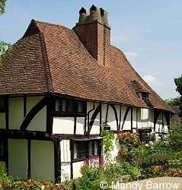This house is over 600 years old
Who owns houses in England?
More people are buying their own homes than in the past. About two thirds of the people in England and the rest of Britain either own, or are in the process of buying, their own home. Most others live in houses or flats that they rent from a private landlord, the local council, or housing association.
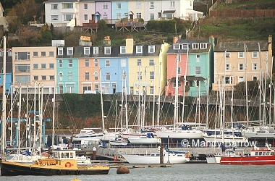
People buying their property almost always pay for it with a special loan called a mortgage, which they must repay, with interest, over a long period of time, usually 25 years.
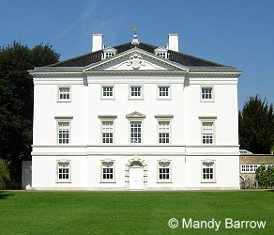
What are houses in England like?
Most houses in England are made of stone or brick from the local area where the houses are built. The colours of the stones and bricks vary across the country.
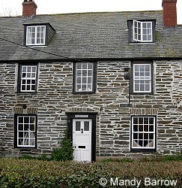 | 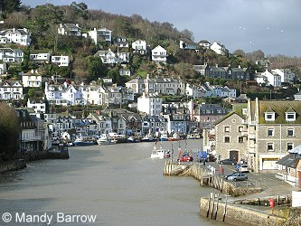
Types of houses in England
England has many types of homes. In the large cities, people often live in apartments, which are called flats. In most towns, there are streets of houses joined together in long rows. They are called terraced houses.
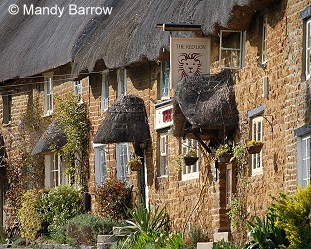
The main types of houses in England are:
- Detached (a house not joined to another house)
- Semi-detached (two houses joined together)
- Terrace (several houses joined together)
- Flats (apartments)
Photos of the different types of houses
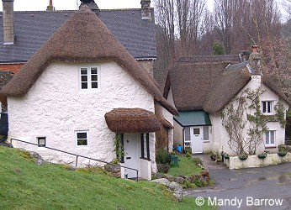
Census 2001: Housing
The most popular type of home in England is semi-detached (more than 27% of all homes), closely followed by detached then terraced.
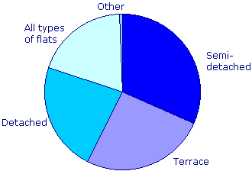
Almost half of London's households are flats, maisonettes or apartments.
Information taken from Census 2001
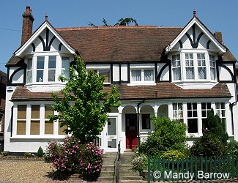
Cost of Houses
A big problem in England is the rising cost of houses. In 1989 first-time buyers paid an average of around £40,000, but by 2001 this had more than doubled to £85,000.

United States of America 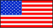

United States – Fact Sheet
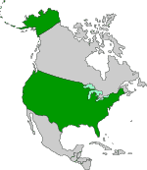
Official name: | United States of America
Abbreviations: | U.S. / U.S.A.
Capital: | Washington, D.C.
Size: | 9,529,063 km² (plus approximately 10,360 km² for outlying territories and other politically associated areas)
Population: | 281.4 million
Borders: | Canada (north), Atlantic Ocean (east), Mexico and Gulf of Mexico (south), Pacific Ocean (west)
Currency: | US Dollar
Official language: | English
Nationality / People | A person of American nationality is an American.
Local time: | New York: 07:54 EST (Tuesday, 18th November 2008)  Los Angeles: 04:54 PST (Tuesday, 18th November 2008)

USA Time Zones
The United States spans 6 time zones. It shares the main four time zones with Canada (Eastern Time-6 hod menej ako u nas, Central Time- 7 hod, Mountain Time (texas, utah, denver, Colorado, Arizona, phoenix)- 8 hod and Pacific Time-9 hod).
Hawaii Time-11 hod and Alaska Time-10 hod, are separate Time zones

Other interesting facts:
The United States is the fourth largest country in the world (after Russia, Canada, and China). It consists of 50 states plus Washington D.C. (a federal district) and four outlying territories (Puerto Rico, U.S. Virgin Islands, Guam, American Samoa).
Symbols of U.S. Government:
The Flag
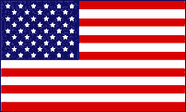
The U.S. flag has undergone many changes since the first official flag of 1777. On June 14, 1777, the Continental Congress passed the first Flag Act, which said that the flag would be made up of thirteen alternating red and white stripes and thirteen white stars on a blue field. Stars have been added to the flag as new states join the union. Currently, the flag contains 50 stars.
Ever wonder why the flag is red, white, and blue? While the flag's colors did not have a specific meaning at the time, the colors were significant for the Great Seal of 1782.
- White: Signifies purity and innocence
- Red: Signifies valor and bravery
- Blue: Signifies Vigilance, perseverance, and justice
Why stars and stripes? Stars are considered a symbol of the heavens and the divine goal to which man has aspired from time immemorial; the stripe is symbolic of the rays of light emanating from the sun.
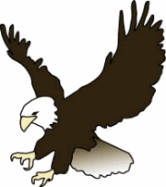
The Bald Eagle
The bald eagle is a large, powerful, brown bird with a white head and tail. The term "bald" does not mean that this bird lacks feathers. Instead, it comes from the word piebald, an old word, meaning "marked with white."
The bald eagle was made the national bird of the United States in 1782. The image of the bald eagle can be found in many places in the U.S., such as on the Great Seal, Federal agency seals, the President's flag, and on the one-dollar bill.
Why was the bald eagle chosen as our national symbol?
The Founding Fathers wanted to choose an animal that was unique to the United States. For six years, the members of Congress engaged in a dispute over what the national emblem should be. As a result of the debate, the bald eagle was chosen because it symbolized strength, courage, freedom, and immortality and that it would look much better as our national symbol.
When Europeans first arrived on the North American continent in the 1600's, there were an estimated 25,000 to 50,000 bald eagles, but populations have since dropped for many reasons. Many eagles were captured for getting too close to poultry or fishing nets; some were captured for falconry; and many eagles were poisoned by pesticides. In 1967, the bald eagle was included on the Endangered Species List. Federal laws, such as the Bald Eagle Protection Act, protect the bald eagle and have led to the recovery of bald eagle populations. In 2007, populations have improved and the the bald eagle was removed from the list.
To learn more, check out the following links:
National Floral Emblem - The Rose
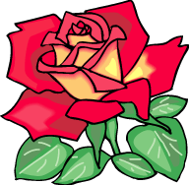
The rose, said to be about 35 million years old, has been used as a symbol of love, beauty, war, and politics throughout the world. The flowers are generally red, pink, white, or yellow and grow naturally throughout North America. The rose became the official flower of the United States in 1986.
In October 1985, the Senate passed a resolution that declared the rose as the National Floral Emblem of the United States. Senate Joint Resolution 159 was passed by the House of Representatives on September 23, 1986.
The resolution asked the president to issue a proclamation declaring the rose as the national flower. A proclamation announces an act by the government and does not have the effect of law.
President Reagan signed the resolution on October 7, 1986 in a ceremony in the White House Rose Garden. On November 20, 1986, President Reagan issued Proclamation 5574: The National Floral Emblem of the United States of America: The Rose.

New York

Statue of Liberty
The (Freiheitsstatue) Statue of Liberty stands on Liberty Island, at the (Mündung) mouth of the Hudson River in New York Harbor. The statue represents the goddess of liberty with a (Fackel) torch in her right hand and a (Tafel) tablet in her left hand. On the tablet you can see the date of the (Unabhängigkeitserklärung) Declaration of Independence “JULY IV MDCCLXXVI” (July 4, 1776).
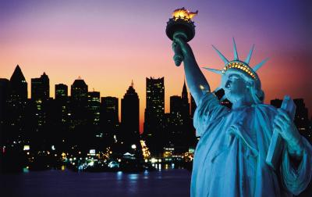
The (Kupfer) copper statue is 46 meters high and was made by Frederic Auguste Bartholdi and Gustave Eiffel (who also built the Eiffel Tower). It was given to the United States by France (anlässlich) on the occasion of the 100th (Jahrestag) anniversary of the Declaration of Independence.

Empire State Building
The Empire State Building was opened on May 1, 1931. It is an office building, but the platform at the top of the building is also a popular tourist attraction.
Its height from bottom to the 102nd floor is 381 meters. Including the (Antennenturm) broadcasting tower, which was added in the 1950s, the total height is 443.5 meters.
Before the attacks on the World Trade Center on September 11, 2001, the Empire State building was the second highest building in New York. The Freedom Tower, which is planned to be constructed on Ground Zero, will again be higher than the Empire State Building.

Central Park
Central Park lies in Manhattan and covers an area of 3.4 km² (4 km × 800 m). It is one of the most famous city parks and not only a popular oasis for New Yorkers, but also for (Zugvögel) migrating birds.
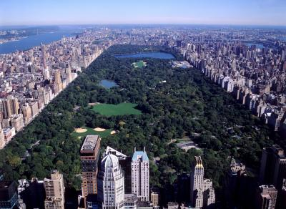

Washington, DC
Washington, DC is the capital of the United States. DC stands for District of Columbia and means that Washington is not part of any (Bundesstaat) federal state, but a (einzigartig) unique (Gebiet) district. The citizens of Washington, DC have no (wählendes Mitglied) voting representation in Congress and are (überhaupt nicht vertreten) not at all represented in the Senate.
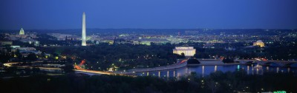

White House
The White House is the working place and (Wohnsitz) residence of the United States President. It was built between 1792 and 1800 and has 132 rooms. There is also a swimming pool, movie theater, tennis court and (Bowlingbahn) bowling lane.
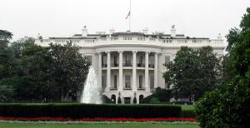

United States Capitol
A long mall connects the White House and the Capitol ( (Sitz) home of the Congress). The House of Representatives is in the south (Flügel) wing and the Senate in the north wing. On (Tag der Amtseinführung) Inauguration Day (January 20), the President holds his (Amtseinführungsrede) inaugural address on the steps of the Capitol and then usually (marschieren) parades from the Capitol to the White House.
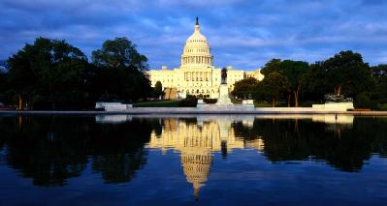

Orlando, Florida

Disney World
Disney World opened in 1971. Disneyland in California already existed at that time, but it had hardly any visitors from the eastern parts of the United States where 75 percent of the country's population live. So Walt Disney decided to build another park in Orlando, Florida with four theme parks:
- The Magic Kingdom
- EPCOT (Experimental Prototype Community of Tomorrow)
- Disney-MGM Studios
- Disney’s Animal Kingdom
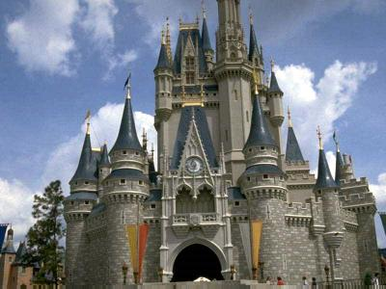

Los Angeles
Los Angeles, also known as L.A., is the second largest city in the United States (after New York). Most (Einwanderer) immigrants to the United States arrive in Los Angeles and many of them stay here. The city is also famous for its two Olympic Games (1932 and 1984).
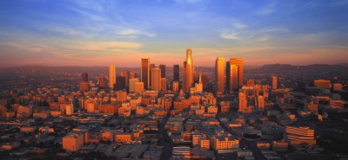

Hollywood
Hollywood is a district of Los Angeles and for a long time it was (nichts weiter als) nothing more but the name of a ranch. In the early 1900s, however, movie companies (entschieden sich) decided to move from New York and New Jersey to California where they had more (Platz) space and better weather. Nestor Studios were the first to (sich niederlassen) settle in the area. But more and more followed and now Hollywood is famous all over the world for its movie studios and stars.
On the Walk of Fame (along Hollywood Boulevard and Vine Street) more than 2,000 (Prominente) celebrities are honored with a star.
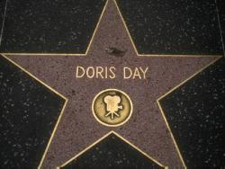

Disneyland (Anaheim, California)
Disneyland is situated in Anaheim, just a little south of the City of Los Angeles. The park opened on July 17, 1955 and was the first Disney Park in the world. It has been visited by more than 500,000,000 people and has several theme parks: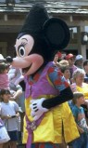
- Adventureland
- Critter Country
- Fantasyland
- Frontierland
- Main Street U.S.A.
- Mickey’s Toontown
- New Orleans Square
- Tomorrowland

Grand Canyon National Park
The Grand Canyon is one of the most spectacular (landschaftliche Sehenswürdigkeiten) natural features on earth. It is listed as one of the Seven Natural Wonders and became a United States national park in 1919. The park covers an area of nearly 5,000 km².
(hier: geformt) Carved by the Colorado River, the Grand Canyon (hier: schneidet sich ein) slices deep into the Colorado Plateau and forms one of the most scenic landscapes in the world. Up to 1963, when the Glen Canyon Dam was built, the Colorado river moved 143 million tons of stones each year.
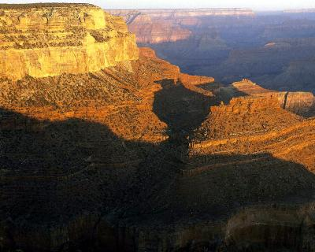

The Grand Canyon Level: intermediate
→ Questions on the text
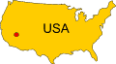The Grand Canyon is one of the most spectacular natural features on earth. It is listed as one of the Seven Natural Wonders and became a United States national park in 1919. The park covers an area of nearly 1,900 square miles altogether.
Carved by the Colorado River, the Grand Canyon slices deep into the Colorado Plateau and forms one of the most scenic landscapes in the world. Its altitudes range from about 1,200 feet above sea level to 8,803 feet. The width of the canyon varies from less than a mile to more than 18 miles; in some places the canyon is more than a mile deep.
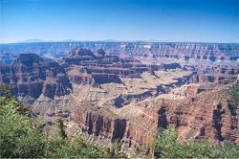Because of the great length and depth of the canyon, the park includes many different physical and biological environments. The climate is varied too, ranging from desert to subarctic climate. This is the same climatic variation that can be found between northern Mexico and central Canada.
299 species of birds, 74 kinds of mammals, 8 species of amphibians, and 40 kinds of reptiles are found in the canyon.
The first inhabitants of the Grand Canyon were the Paleo Indians. They arrived 11,000 years ago and were descendants of Asian people who had migrated to the North American continent at least 25,000 years earlier, during the Ice Age. It was only in 1540 that the Grand Canyon was discovered by white settlers.
The Colorado River has cut its way through the whole canyon, that's 277.7 miles. Up to 1963, when the Glen Canyon Dam was built, the Colorado river moved 143 million tons of stones each year, in 1927 even 480 million tons. The Glen Canyon Dam finally reduced the amount of sediment transported by the river.

Las Vegas
Las Vegas was founded in May 1905. In 1941 the first large hotels with (Spielcasinos) gambling casinos were built. Since then Las Vegas has grown to become the largest city in Nevada and a major tourist attraction.
Staying in Las Vegas can be quite cheap as the rooms are usually not expensive. It’s hard, however, to (der Versuchung widerstehen) resist the temptation of spending lots of money in one of the gambling casinos.
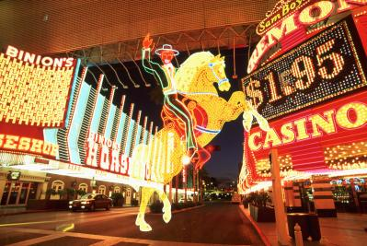

Grammar Exercise on the Text

Keystone (South Dakota)

Mount Rushmore
Mount Rushmore National Memorial Park in Keystone, South Dakota covers an area of 5 km². The rock formation was a (heilig) sacred Indian site once and became a national (Denkmal) memorial on March 3, 1925.
Most visitors come to this place to see the famous (Büsten) busts of the presidents George Washington, Thomas Jefferson, Theodore Roosevelt, and Abraham Lincoln (from left to right). The busts are about 18 meters high and were (hier: gehauen) carved by 400 workers between 1927 and 1941.
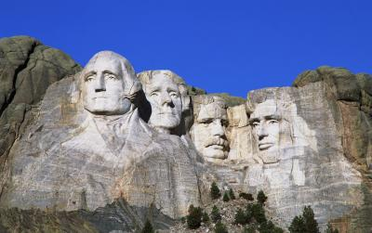

The Education System in the USA

Introduction
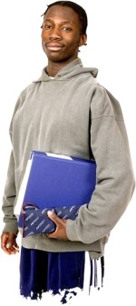In the USA, children start school when they are five or six years old. Depending on the state, schooling is compulsory until the age of 16 or 18. Children younger than five can go to a nursery school or preschool.
At the age of five or six, the children attend elementary school (also known as grade school or grammar school), which last six years. The fist year at elementary school is called kindergarten.
After elementary school, students attend middle school (also known as junior high school) for three years. Then they continue at high school. In some states, students have to stay in school until they are 18 years old. In other states they may leave school at 16 or 17 with parental permission.
Age | School
< 5 | nursery school / preschool
5-11 | elementary school
11-14 | middle school / junior high school
14-18 | high school / senior high school
When students in the USA say what year they are in, they usually use ordinal numbers, e. g. ‘tenth grade’. (In the UK students would use cardinal numbers, e. g. ‘year ten’.)

Classes
At elementary school pupils primarily learn how to read, write and count. There are about 20 to 30 pupils in one class.
At junior and senior high school, mandatory subjects are English, maths, biology, chemistry, physics, physical education and history. Schools also offer optional courses from which the students can choose, e. g. art, modern languages, computers. Physical education is a very important subject in the United States – many students participate in sports programs.
Gifted and talented students can take advanced courses in their schools or attend additional courses at community colleges in the afternoons or during the holidays. Often such courses are later acknowledged by universities, and can facilitate early graduation.

Grading Scale
In the USA (as in other English speaking countries) letter grades are used in reports.
- A > 90 % (excellent)
- B > 80 % (very good)
- C > 70 % (improvement needed)
- D > 60 % (close fail)
- E > 50 % (fail)
- F < 50 % (fail)
In general, only grades A to C are a 'pass' – a plus (+) or minus (-) might be added (e. g. A-, B+).

Different Kinds of Schools
Most students in the USA are enrolled in public schools. These are financed through taxes, so parents do not have to pay for their children's education. About 10 % of US students attend private schools, where parents have to pay a yearly fee.
Another option is homeschooling: approximately 1-2 % of parents in the USA educate their children at home. Some reasons for homeschooling are religious views, special needs (e. g. handicapped children), or problems in traditional schools (bullying, drugs etc.). However, there is also opposition to homeschooling claiming that the students have difficulties socializing with others, that homeschooling (often carried out by the parents) is of a poor academic quality and that (especially concerning religion) extremist views might be encouraged.

School Uniforms
It is not common for students in the USA to wear school uniforms, but many schools have dress codes telling students what kind of clothing is or is not allowed in school. Some schools (especially private schools) have started to require their students to wear school uniforms in order to improve school discipline and avoid 'fashion cliques'.

US Presidents
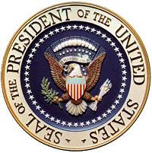
• Ronald Reagan (1981-1989)
• George Bush (1989-1993)
• Bill Clinton (1993-2001)
• George W. Bush (since 2001)
Barack Obama 2009

Thanksgiving
Questions on the text
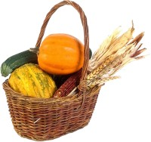Thanksgiving is a holiday in the United States and Canada; it is closely related to European harvest festivals.
The first Thanksgiving was held in 1621. After a good harvest, the Pilgrim Fathers, who had travelled to America aboard the Mayflower, organised a great feast. They also invited their Indian friends, who had helped the Pilgrims through their first year in the New World.
After that first Thanksgiving, the holiday was not observed regularly and not usually in autumn. In 1863, however, President Abraham Lincoln proclaimed an annual Thanksgiving Day to be celebrated on the last Thursday of November. In 1939, President Roosevelt changed the date to the penultimate Thursday of November to enlarge the Christmas shopping period, which starts after the Thanksgiving celebrations. Not all states followed Roosevelt’s declaration though, and so in 1941 the United States Congress finally decided to celebrate Thanksgiving on the fourth Thursday of November (which sometimes is the last, sometimes the penultimate Thursday).
In the United States, Thanksgiving lasts four days now because most people also get the Friday off. The holiday is celebrated with family and friends, and a huge dinner is served in the early afternoon or evening. The traditional Thanksgiving dinner is a roasted turkey served with stuffing, mashed potatoes, cranberry sauce, green beans and various pies for dessert.
In Canada, the first Thanksgiving was celebrated in 1710. For about 200 years, it was held for example when a royal child was born or when a battle was won. It became an annual holiday in 1931 and is now celebrated on the second Monday of October.

Day of Independence (4 July)
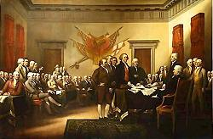Independence Day is the most important secular holiday in the United States. It is celebrated on 4 July and marks America's independence from Britain.
As you surely know, Britain once had various colonies on the American continent. Many British people moved to those colonies, and during the first 150 years of colonisation Britain did not interfere in colonial affairs. In 1763, however, Britain suddenly changed its policy: it enforced restrictions on American trade and manufacturing and tried to levy more and more taxes on the colonists, e.g. taxes on paper, sugar and tea. A high tax on tea finally provoked protest: on 16 December, 1773, some colonists dressed as Native Americans boarded British ships and threw tea into Boston harbour; that event became known as The Boston Tea Party. Britain in return passed another law in 1774—the Five Intolerable Acts—which wasn't accepted by the colonists. So in 1775, the War of Independence began.
At the beginning of the conflict, only few wanted to be independent from Britain. Most colonists thought that the English Parliament was to blame for the high taxes, and so they asked King George III for support. Seeing, however, that the king didn't help them but instead sent an army to fight the colonists, more and more colonists eventually wanted independence from Britain.
On 2 July, 1776, Congress voted for independence. The content of the declaration was under discussion for two days before, on 4 July, the Declaration of Independence was accepted. (The original document can now be seen in the National Archives exhibition hall in Washington, D.C.)
Whilst in 1776, colonists were still fighting for their independence on 4 July, today there are celebrations everywhere throughout the country. In parades lots of people are dressed in 18th century uniforms, and in the evenings you can enjoy breathtaking fireworks.
Christmas in United States of America
Santa Claus was born in US in the 1860's he was named this as he had a white beard and a belly, so he was named Santa Claus as this was the Dutch word for St Nicholas, Sintaklaas. Although the Dutch had bought him with them in the 17th century, he did not become an important person at Christmas until the Novelist Washington Irving put him in a novel that he wrote in 1809. This first Santa Claus was still known as St. Nicholas, he did smoke a pipe, and fly around in a wagon without any reindeer, but he did not have his red suit or live at the North Pole, he did however bring presents to children every year.
In 1863 He was given the name Santa Claus and bore the red suit, pipe, and his reindeer and sleigh.
Now Christmas celebrations vary greatly between regions of the United States, because of the variety of nationalities which have settled in it.
In Pennsylvania, the Moravians build a landscape, called a putz - under the Christmas tree, while in the same state the Germans are given gifts by Belsnickle, who taps them with his switch if they have misbehaved.
Early European settlers brought many traditions to the United States. Many settled in the early days in the South, these settlers would send Christmas greetings to their distant neighbors by shooting firearms and letting off fireworks. In Hawaii this practice is still in use as under the sunny skies, Santa Claus arrives by boat and Christmas dinner is eaten outdoors.
In Alaska, a star on a pole is taken from door to door, followed by Herod's Men, who try to capture the star. Colonial doorways are often decorated with pineapple, a symbol of hospitality.
In Alaska, boys and girls with lanterns on poles carry a large figure of a star from door to door. They sing carols and are invited in for supper.
In Washington D.C., a huge, spectacular tree is lit ceremoniously when the President presses a button and turns on the tree's lights.
In Boston, carol singing festivities are famous. The singers are accompanied by hand bells.
In New Orleans, a huge ox is paraded around the streets decorated with holly and with ribbons tied to its horns.
In Arizona, the Mexican ritual called Las Posadas is kept up. This is a ritual procession and play representing the search of Mary and Joseph for a room at the inn. Families play the parts and visit each other's houses enacting and re-enacting the drama and, at the same time, having a look at each family's crib.
In Hawaii, Christmas starts with the coming of the Christmas Tree Ship, which is a ship bringing a great load of Christmas fare. Santa Claus also arrives by boat.
In California, Santa Claus sweeps in on a surf board.
In America the traditional Christmas dinner is roast turkey with vegetables and sauces. For dessert it is rich, fruity Christmas pudding with brandy sauce. Mince pies, pastry cases filled with a mixture of chopped dried fruit.
The majority of Americans celebrate Christmas with the exchange of gifts and greetings and with family visits. For many, the day begins on Christmas Eve with the Midnight Mass. At Christmas it snows in many states, so dinner is usually eaten indoors. Dinner usually is roast turkey, goose, duck or ham served with cranberry sauce, then plum pudding or pumpkin pie followed by nuts and fruit.
American homes are decorated with holly, mistletoe and branches of trees, most have a Christmas tree hung with electric lights, tinsel, baubles, and strings of popcorn and candy canes.
In Colorado, an enormous star is placed on the mountain, it can be seen for many kilometers around, while in Bethlehem, Pennsylvania, a star is lit in early December.
Polish Americans on Christmas Eve spread hay on their kitchen floor and under the tablecloth to remind them of a stable and a manger. When they make up the table for dinner two extra places are set up for Mary and the Christ Child in case they should knock at the door to ask for shelter.
In Philadelphia, a procession called a mummers parade runs for a whole day with bands, dancers and people in fancy dress.
There are two homes for Santa Claus in the United States one is in Torrington, Connecticut, where Santa and his helpers give out presents. The other home is in Wilmington, New York, where a village for Santa and his reindeer is located.
In Arizona they follow the Mexican traditions called Las Posadas. Families play out the parts of Mary and Joseph searching for somewhere to stay. They form a procession and visit their friends' and neighbors' homes where they admire each family's Nativity crib. In parts of New Mexico, people place lighted candles in paper bags filled with sand on streets and rooftops to light the way for the Christ Child.

Sports in the United States

From Wikipedia, the free encyclopedia
Jump to: navigation, search
Sports in the United States are an important part of the national culture. However, the sporting culture of the U.S. is different from that of many other countries. Compared to any other nation, Americans prefer a unique set of sports. For example, soccer, the most popular sport in the world, is not as popular in the U.S. compared to the four most popular team sports, namely, American football, basketball, baseball, and ice hockey. The major leagues of each of these sports enjoy massive media exposure and are considered the preeminent competitions in their respective sports in the world. The preeminence of the major leagues is partially attributed to their strong financial power and huge domestic market, as well as the fact that relatively few other countries play some of their dominant sports, like American football, to any significant extent.
In addition to the difference of popular sports, sports are also organized differently in the United States. There is no system of promotion and relegation like sports in Europe and major sports leagues operate as associations of franchises. Moreover, all major sports leagues use the same type of schedule with a playoff tournament after the regular season. Also, unlike many other countries, schools and colleges and universities sports competitions play an important role in the American sporting culture.

American football

From Wikipedia, the free encyclopedia
Jump to: navigation, search

For other uses, see American football (disambiguation) and Football.
American football
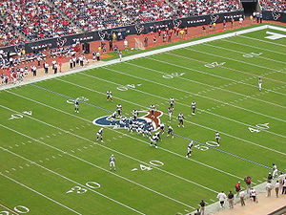
American football game between the Tennessee Titans and the Houston Texans in 2005.
Nickname(s) | Football, Gridiron football
First played | November 6, 1869, Rutgers University vs. Princeton University
Characteristics
Team members | 11 at a time
Ball | Football
American football, known in the United States and Canada simply as football,^{[1]} is a competitive team sport known for mixing strategy with physical play. The objective of the game is to score points by advancing the ball^{[2]} into the opposing team's end zone. The ball can be advanced by carrying it (a running play) or by throwing it to a teammate (a passing play). Points can be scored in a variety of ways, including carrying the ball over the opponent's goal line; catching a pass from beyond that goal line; kicking the ball through the goal posts at the opponent's end zone; and tackling an opposing ballcarrier within his end zone. The winner is the team with the most points when the time expires.
The sport is also played outside the United States. National leagues exist in Germany, Italy, Switzerland, Finland, Sweden, Japan, Mexico, Israel, Spain, Austria and several Pacific Island nations. The National Football League, the largest professional American football league in the world, ran a developmental league in Europe from 1991–1992 and then from 1995–2006.
American football is closely related to Canadian football, but with significant differences. Both sports originated from rugby football.

Association football

From Wikipedia, the free encyclopedia
(Redirected from Soccer)
Jump to: navigation, search

"Soccer" redirects here. For other uses, see Soccer (disambiguation).
Association football
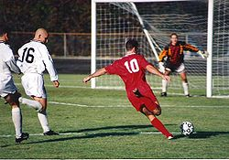
An attacking player (No 10) attempts to kick the ball past the goalkeeper to score a goal.
Highest governing body | FIFA
Nickname(s) | Football, Soccer, Futbol, Footy/Footie
Characteristics
Contact | Contact
Team members | 11 at a time
Category | Indoor or Outdoor
Ball | Football
Olympic | 1900
Association football, more commonly known as football or soccer, is a team sport played between two teams of eleven players, and is widely considered to be the most popular sport in the world.^{[1][2][3]} It is a football variant played on a rectangular grass or artificial turf field, with a goal at each of the short ends. The object of the game is to score by manoeuvring the ball into the opposing goal. In general play, the goalkeepers are the only players allowed to use their hands or arms to propel the ball; the rest of the team usually use their feet to kick the ball into position, occasionally using their torso or head to intercept a ball in midair. The team that scores the most goals by the end of the match wins. If the score is tied at the end of the game, either a draw is declared or the game goes into extra time and/or a penalty shootout, depending on the format of the competition.
The modern game was codified in England following the formation of The Football Association, whose 1863 Laws of the Game created the foundations for the way the sport is played today. Football is governed internationally by the Fédération Internationale de Football Association (International Federation of Association Football), commonly known by the acronym FIFA. The most prestigious international football competition is the FIFA World Cup, held every four years. This event, the most widely viewed in the world, boasts an audience twice that of the Summer Olympic Games.^{[4]}

Ice hockey

From Wikipedia, the free encyclopedia
Jump to: navigation, search
For other uses, see Ice hockey (disambiguation)
Ice hockey
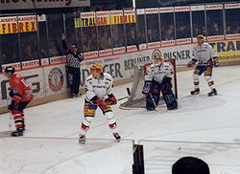
Two defencemen and a goaltender protect their goal. The referee's raised arm indicates that he intends to call a penalty.
Highest governing body | International Ice Hockey Federation
Nickname(s) | Hockey
First played | March 3, 1875, Victoria Skating Rink, Montreal, (first organized indoor game)
Characteristics
Contact | Collision
Team members | Five skaters and one goaltender
Olympic | 1920
Ice hockey, often referred to simply as hockey, is a team sport played on ice. It is a fast paced and physical sport. Ice hockey is most popular in areas that are sufficiently cold for natural reliable seasonal ice cover like Canada, Northern United States and Russia, though with the advent of indoor artificial ice rinks it has become a year-round pastime at the amateur level in major metropolitan areas such as cities that host a National Hockey League (NHL) or other professional-league team. It is one of the four major North American professional sports, and the National Hockey League (NHL) at the highest level, and the Canadian Women's Hockey League (CWHL) and the Western Women's Hockey League (WWHL) at the highest level of women's ice hockey in the world. It is the official national winter sport of Canada, where the game enjoys immense popularity. Only six of the thirty NHL franchises are based in Canada, but Canadian players outnumber Americans in the league.
While there are 66 total members of the International Ice Hockey Federation (IIHF), Canada, the Czech Republic, Finland, Russia, Slovakia, Sweden and the United States have finished in most of the coveted 1st, 2nd and 3rd places at IIHF World Championships. Of the 63 medals awarded in men's competition at the Olympic level from 1920 on, only six did not go to the one of those countries, or a former entity thereof, such as Czechoslovakia or the Soviet Union. Only one of those six medals was above bronze.^{[1]} Those seven nations have also captured 162 of 177 medals awarded at 59 non-Olympic IIHF World Championships, and all medals since 1954.^{[2]} Likewise, all nine Olympic and 27 IIHF World Women Championships medals have gone to one of those seven countries.^{[3][4]}
People in america
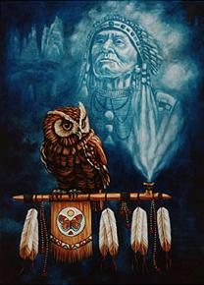

LONG BEFORE the white man set foot on American soil, the American Indians, or rather the Native Americans, had been living in America. When the Europeans came here, there were probably about 10 million Indians populating America north of present-day Mexico. And they had been living in America for quite some time. It is believed that the first Native Americans arrived during the last ice-age, approximately 20,000 - 30,000 years ago through a land-bridge across the Bering Sound, from northeastern Siberia into Alaska. The oldest documented Indian cultures in North America are Sandia (15000 BC), Clovis (12000 BC) and Folsom (8000 BC)
Although it is believed that the Indians originated in Asia, few if any of them came from India. The name "Indian" was first applied to them by Christopher Columbus, who believed mistakenly that the mainland and islands of America were part of the Indies, in Asia.
So, when the Europeans started to arrive in the 16th- and 17th-century they were met by Native Americans, and enthusiastically so. The Natives regarded their white-complexioned visitors as something of a marvel, not only for their outlandish dress and beards and winged ships but even more for their wonderful technology - steel knives and swords, fire-belching arquebus and cannon, mirrors, hawkbells and earrings, copper and brass kettles, and so on.
However, conflicts eventually arose. As a starter, the arriving Europeans seemed attuned to another world, they appeared to be oblivious to the rhythms and spirit of nature. Nature to the Europeans - and the Indians detected this - was something of an obstacle, even an enemy. It was also a commodity: A forest was so many board feet of timber, a beaver colony so many pelts, a herd of buffalo so many robes and tongues. Even the Indians themselves were a resource - souls ripe for the Jesuit, Dominican, or Puritan plucking.
It was the Europeans' cultural arrogance, coupled with their materialistic view of the land and its animal and plant beings, that the Indians found repellent. Europeans, in sum, were regarded as something mechanical - soulless creatures who wielded diabolically ingenious tools and weapons to accomplish mad ends.
The Europeans brought with them not only a desire and will to conquer the new continent for all its material richness, but they also brought with them diseases that hit the Indians hard. Conflicts developed between the Native Americans and the Invaders, the latter arriving in overwhelming numbers, as many "as the stars in heaven". The Europeans were accustomed to own land and laid claim to it while they considered the Indians to be nomads with no interest to claim land ownership. The conflicts led to the Indian Wars, the Indian Removal Act empowered by President Andrew Jackson in 1830 and other acts instituted by the Europeans in order to accomplish their objectives, as they viewed them at the time. In these wars the Indian tribes were at a great disadvantage because of their modest numbers, nomadic life, lack of advanced weapons, and unwillingness to cooperate, even in their own defense.
The end of the wars more or less coincided with the end of the 19th century. The last major war was not really a war, it was a massacre in 1890 where Indian warriors, women, and children were slaughtered by U.S. cavalrymen at Wounded Knee, South Dakota, in a final spasm of ferocity.
A stupefying record of greed and treachery, of heroism and pain, had come to an end, a record forever staining the immense history of the westward movement, which in its drama and tragedy is also distinctively and unforgettably American.
Undersigned being an European emigrating to the U.S. during the latter part of the 20th century, cannot fully comprehend what happened during the past few centuries. I am sure many descendants of emigrants as well as many Native Americans feel the same way. We are all a product of our time and the circumstances prevalent at the time. If I had lived with the Europeans in America during the 19th century, would I have embraced what was going on then? If I had lived with the Germans in the 1930s and 40s, would I have embraced what was going on in Germany then? If I had lived in Scandinavia during medieval time witnessing the horrors of slavery and killings, would I have embraced what was going on then? (The Nordic countries practiced slavery during the middle ages, a master could for any reason kill his slave. Abolished in 1335)
These are hard questions for anyone to honestly answer. It is easy to toss around opinions now, at the end of the 20th century being conveniently removed from circumstances and conditions in a distant and foreign time.
This website will try to present as a true and accurate picture as possible of the past, but not dwell on it. However, it is important for one sole reason and that is to learn from the past and move into the 21st century as better human beings. After all, we are ONE people under God and we can only look back to the past as what it is - history. Now we attempt to cooperate to the best of our ability in the present and we are looking forward to the future for a better world. Let us once again cross the Bering land-bridge and sail the Mayflower, but this time together for the common goal of building up mutual respect and trust.
The best way to accomplish this goal, we believe, is for this website to contribute by presenting links to the most sincere, factual, reliable and honest web-sites around on this subject and let interested parties actively participate. We will try to cover all aspects of our common history in regards to the history and development of the west. You will find many Native American web-sites with an abundance of facts and sources of information here. Please join in if you think you have something to contribute!
New England
New England is a region of the United States located in the northeastern corner of the country, bounded by the Atlantic Ocean, Canada and New York State, and consisting of the modern states of Maine, New Hampshire, Vermont, Massachusetts, Rhode Island, and Connecticut.^{[6]}
In one of the earliest English settlements in the New World, English Pilgrims fleeing religious persecution in Europe first settled in New England in 1620, in the colony of Plymouth. In the late 18th century, the New England colonies would be among the first North American British colonies to demonstrate ambitions of independence from the British Crown, although they would later oppose the War of 1812 between the United States and Britain.
In the 19th century, it played a prominent role in the movement to abolish slavery in the United States, hosted the first pieces of American literature and philosophy, was home to the beginnings of free public education, and was the first region of the United States to be transformed by the North American Industrial Revolution.^{[7]}

